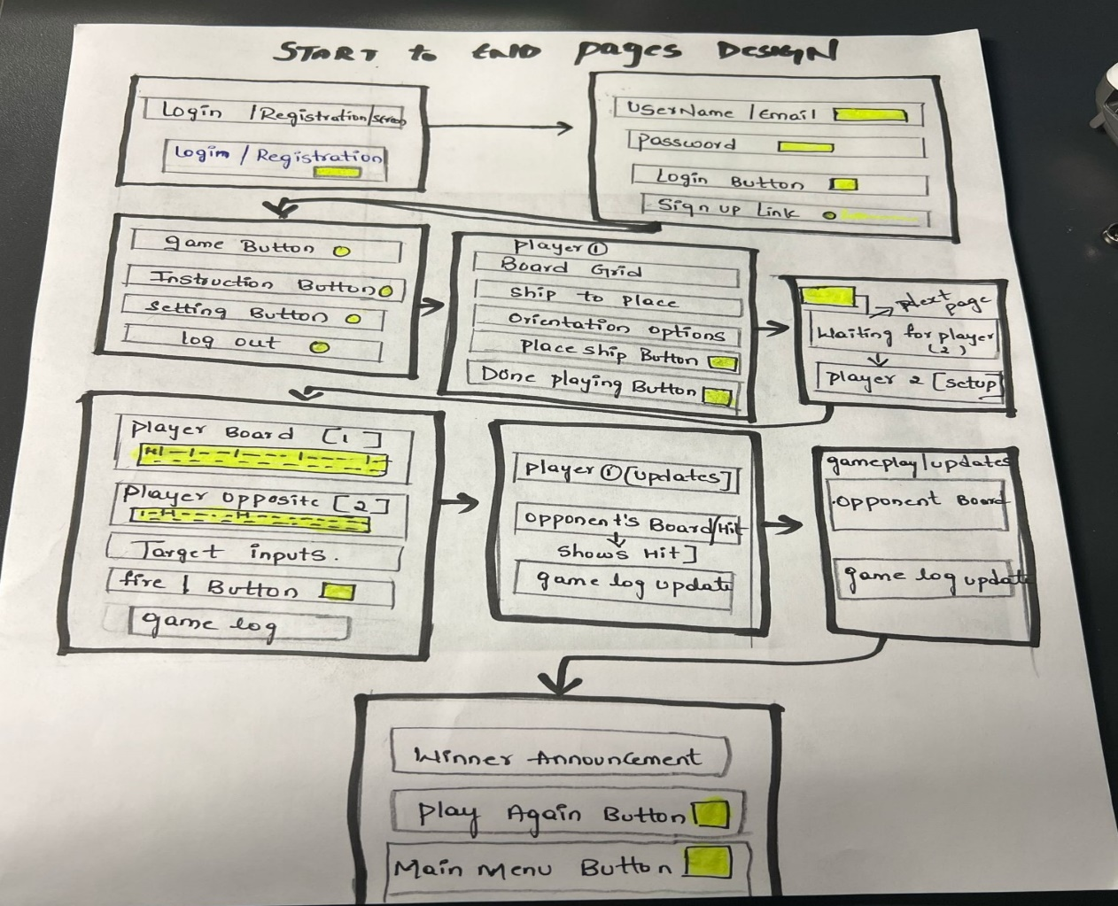

**Review Session**

* **Clarity:** In general, I found the user flow intuitive and was able to navigate the app with relative ease. Nonetheless, the particular action of setting ships on the grid could be more clearly demonstrated.
* **Completeness:** 'The prototype had the fundamental parts of the game, which included account creation and the main gameplay loop. Including a confirmation step after ship placement would enhance the control users feel when placing their ships.
* **Consistency:** “The refined graphic style was kept consistent throughout the screens and was aids in an overall integrated feel. The emphasis of important action buttons could have been more consistently applied.
* **Scalability:** “In the future, it looks like the grid-based system can be modified for different sized boards. Adding new gameplay features will, however, need some thought with regard to the current screen layouts.”
* **Usability:** "Being able to show both game boards at the same time is a good usability feature for monitoring progress. The visual indication for hits on the opponent's board may need to be enhanced to ensure they are more prompt."
* **Adherence to Requirements**: "The prototype implements the primary features of a Battleship game with user profiles. It would be easier if all basic requirements were mapped to particular user interface components."
* **Technical Feasibility:** "It appears that the basic game features can be done with the most common development tools. The proper implementation of the user identification system will be an important technical detail."
* **Optimization Opportunities**: “Even though the paper prototype does not have game boards, game board performance will still need to be optimized in its digital form. Think over the data structures for optimal flow when playing the game.
* **Security Consideration**: "The inclusion of user accounts highlights the need for secure password management practices from the outset. Future iterations should detail the intended security measures."
* **Innovation and Creativity**: "The design provides a solid foundation for a classic game experience. Exploring unique gameplay elements or visual themes could differentiate the application."